My Favorite Disney Movie! 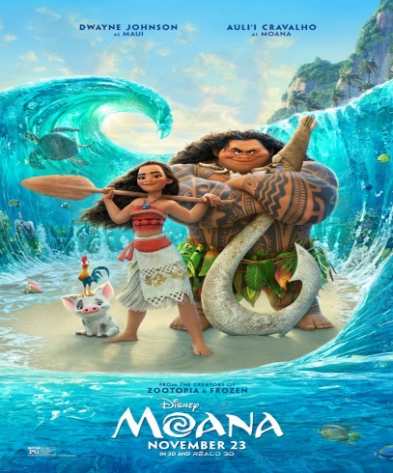

AT HOME LEARNING-January 14-22

Directions: Choose ONE from the following full-length movie on YouTube. Watch the movie and complete the daily assignments. Write the title of the movie you chose one each assignment.

**UP**

[**https://www.youtube.com/watch?v=HawZiwqyrJc**](https://www.youtube.com/watch?v=HawZiwqyrJc)

**MOANA**

[**https://www.youtube.com/watch?v=EXQZKwjNCC4**](https://www.youtube.com/watch?v=EXQZKwjNCC4)

**INSIDE OUT**

[**https://www.youtube.com/watch?v=SvoycpSKCIw**](https://www.youtube.com/watch?v=SvoycpSKCIw)

|  |  |  |  |  |
| --- | --- | --- | --- | --- |
| **Monday** | **Tuesday** | **Wednesday** | **Thursday** | **Friday** |
| Students will write one good sentence about each character. | Students will write one good paragraph describing one or more settings in the movie. | Students will fold their paper into three equal parts. Label the parts beginning, middle and end. Write three or more sentences about each part of the story. | Students will write a paragraph describing the problem in the story and how it is solved by the end of the movie. | Students will draw a picture about their favorite part of the movie. Write one or more sentence to tell about your picture. |

